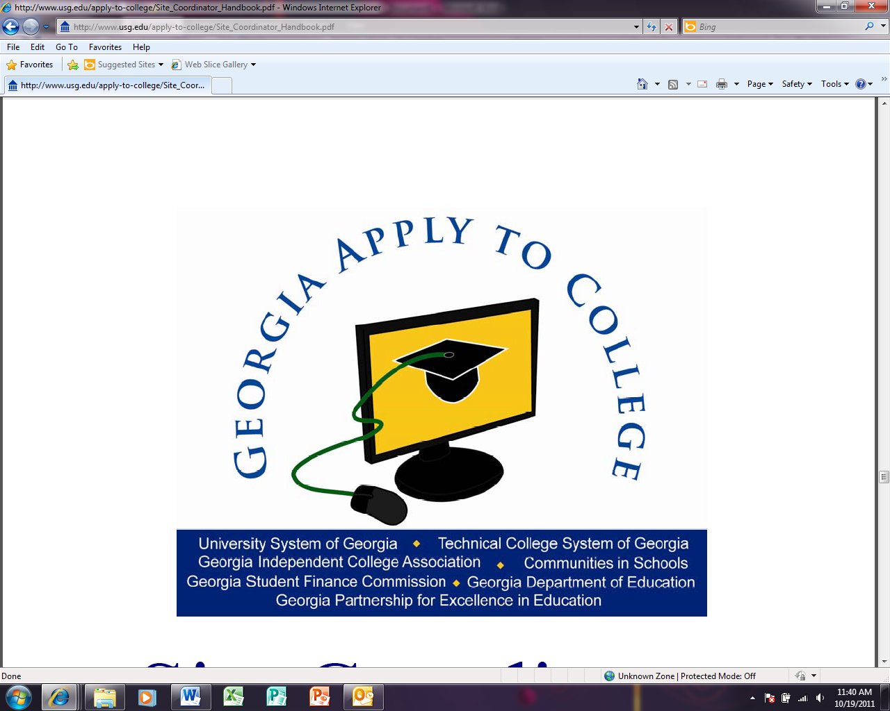

|  |  |
| --- | --- |
| Dear Senior Parent(s)/Guardian(s), | October 21, 2011 |

Centennial High School is excited to announce that our school has been selected to hold a **Georgia Apply to College** (GAC) event. Our event will be held on **Thursday, November 17th from 8:30am – 4:30pm**. During our Georgia Apply to College event, all of our seniors will be given the opportunity in their English classes to apply to college using GAcollege411.org, Georgia’s online resource for planning, applying and paying for college.

Volunteers, many of whom will be staff from local colleges, businesses and community organizations, will be on hand to assist students as they work on their application(s) for college admission. In preparation for the event, your student will need to complete college research to ensure that he/she has a college in mind that will be a good match. In addition, students will be asked to gather the information that they will need to complete an application for college admission and may need your assistance. This information may include the following:

• Social Security Number

• Place of birth

• Residency information, such as tax, employment, driver’s license information

• Citizenship information

• Immediate family military information

• Previous high school information

Students may either submit their application(s) during the event or save it to submit at a later time. On the day of our event, we will encourage students who do not have access to a payment method at school to save their application to submit at home, if possible. As another option, in the past, some students have elected to purchase a prepaid gift card, such as a Visa gift card, in an amount sufficient to cover their application fee and to bring that to school. Students who may qualify for an application fee waiver, such as the College Board or ACT fee waiver, should discuss this option with their counselor prior to the event to obtain the necessary paperwork.

If you have any questions regarding this exciting program, please do not hesitate to contact your student’s counselor or call the Centennial Counseling Office at 770-650-4260. Thank you in advance for your support of this initiative to make college a part of your student’s future!

Sincerely,

**Shellie Caplinger Ed.S., NBCC**

Professional School Counselor

Centennial High School

770-650-4260

[www.mycentennialcounseling.com](mailto:caplinger@fultonschools.org)