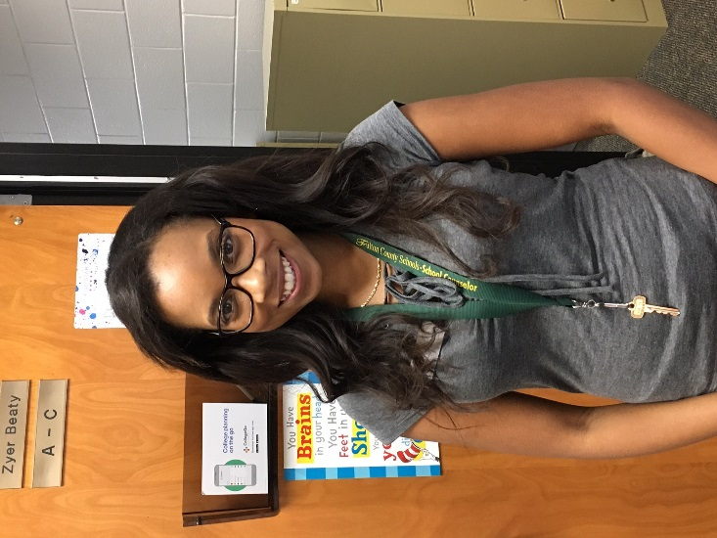 | Counselor (A-C):  Zyer Beaty  Beaty@fultonschools.org
 | Counselor (D-Gol & AVID)/Department Chair:  Shellie Marino  MarinoS1@fultonschools.org
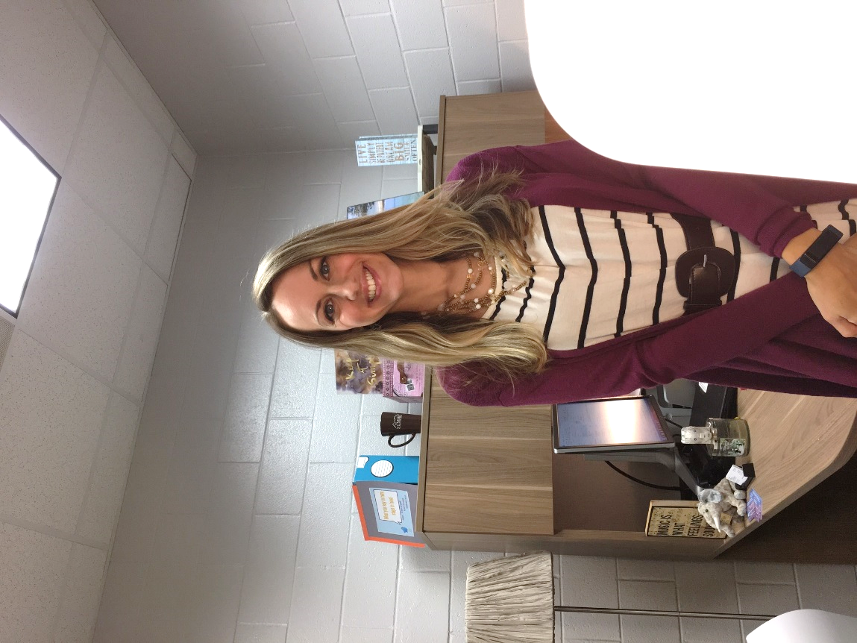 | Counselor (Gom-Mart):  Heidi Graver  GraverH@fultonschools.org
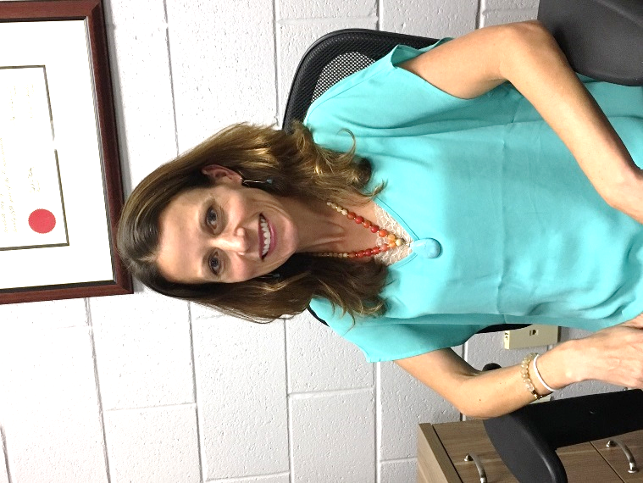 | Counselor (Maru-Sam):  Melissa Freeman  FreemanMA@fultonschools.org
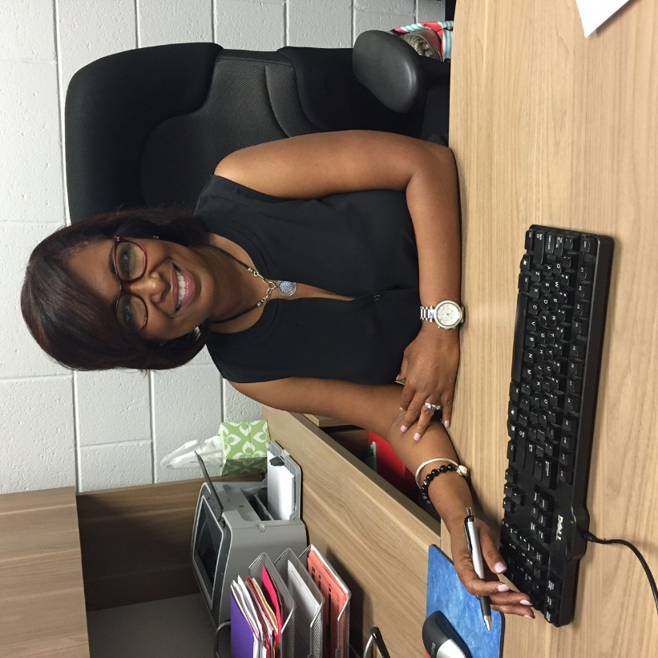 | Counselor (Sand-Z):  Hella Peart  Peart@fultonschools.org
Photo coming soon! | Registrar  Lisa Anderson  AndersonL4@fultonschools.org
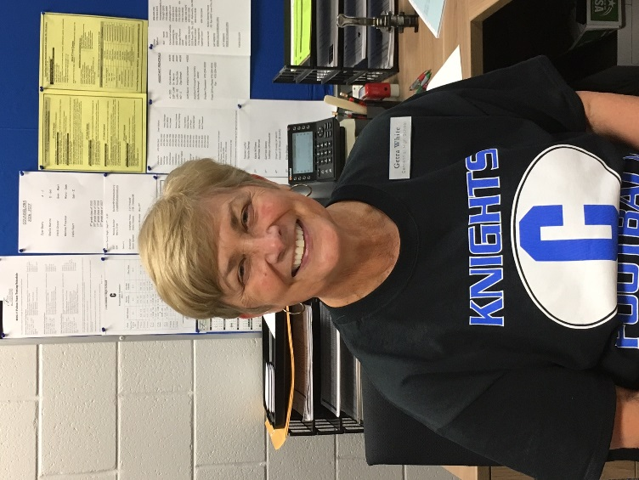 | Counseling & Athletic Secretary:  Getra White  WhiteF@fultonschools.org
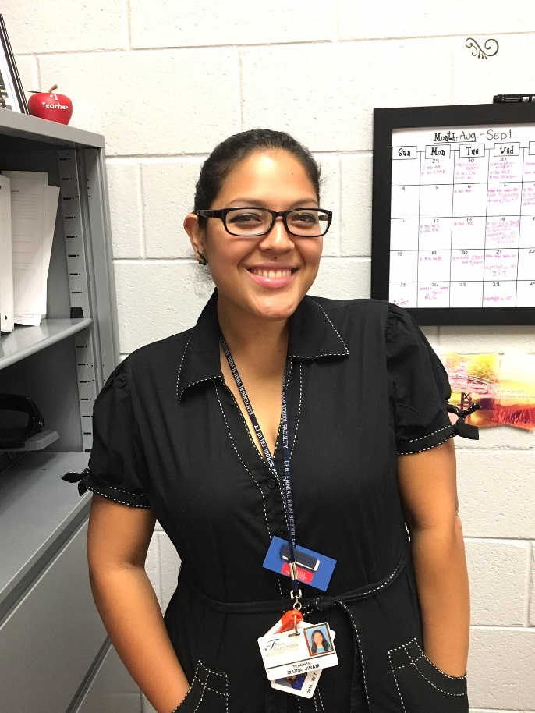 | Graduation Coach  Maria Jiram  JiramM@fultonschools.org
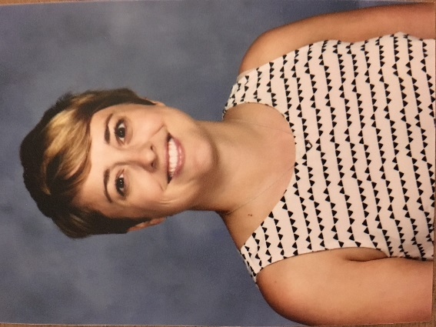 | School Social Worker  Kristi Barnes  BarnesK1@fultonschools.org
Photo coming soon! | Spanish Parent Liaison  Norma Escalera-Smith  ESmith@fultonschools.org

