**10th Grade Guidance & BRIDGE Activity**

**INSTRUCTIONS**

* Open **GOOGLE CHROME** and go to **cis360.org**. Where it says Login, enter the following Username and Password – type it exactly as it is written below

**Username**: **Georgia-ae** **Password**: **CISGeorgia&2019**

You will see “CAREER INFORMATION SYSTEM” at the top.

Underneath Career Information System, click on **ASSESSMENTS** on the blue bar

Click on the light green box: **Ability Explorer**

**Ability Explorer**

**This assessment has 104 statements to read. You will choose your response to each statement by clicking on the “face” that represents your ability or interest level.**

**Read all questions carefully and answer honestly!**

If you need to go back a question to change your answer, please use the green back arrow

* Click the green **START** box
* Once you answer all 104 questions, you will see **Ability Explorer: Results** page

**Once you see “Results”...**

* **Right click** on the webpage and **go to “Save as”**
* **Save “Career Information System” as a webpage** on your desktop or to a safe folder on your computer to keep for later. Do not change the file name or it may not save correctly!
* **\*\*\*Raise your hand** – the counselor will come to check you for completion***

**Worksheet**

* **Write** your **BEST MATCH** on your worksheet
* **Check off if you scored high, medium, or low** for each Ability area,

*AND* **write in the number score** for each area

***THEN,***

Click on **Your Best Match** on the webpage



* This page will help you explore your skills in the career cluster that best matches your results
* **To complete your worksheet,** please go to the bottom of the webpage to

**Careers on Your List**

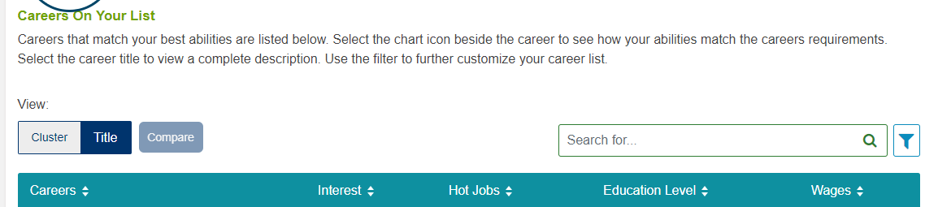

Look through the careers that match your interest, HOT JOBS in demand, education levels, and wages $$

***THEN,***

* **Write** 3 careers that you are interested in learning more about **on your worksheet**

With the time left in class, **click on one** (or more) **careers** that you wrote down on your worksheet to view additional facts, details about the career, and more!

Please turn in your instructions sheet and worksheet to the counselor when you are complete!