9th Grade Bridge Activity – Student Instructions
Log on to Naviance through Classlink.
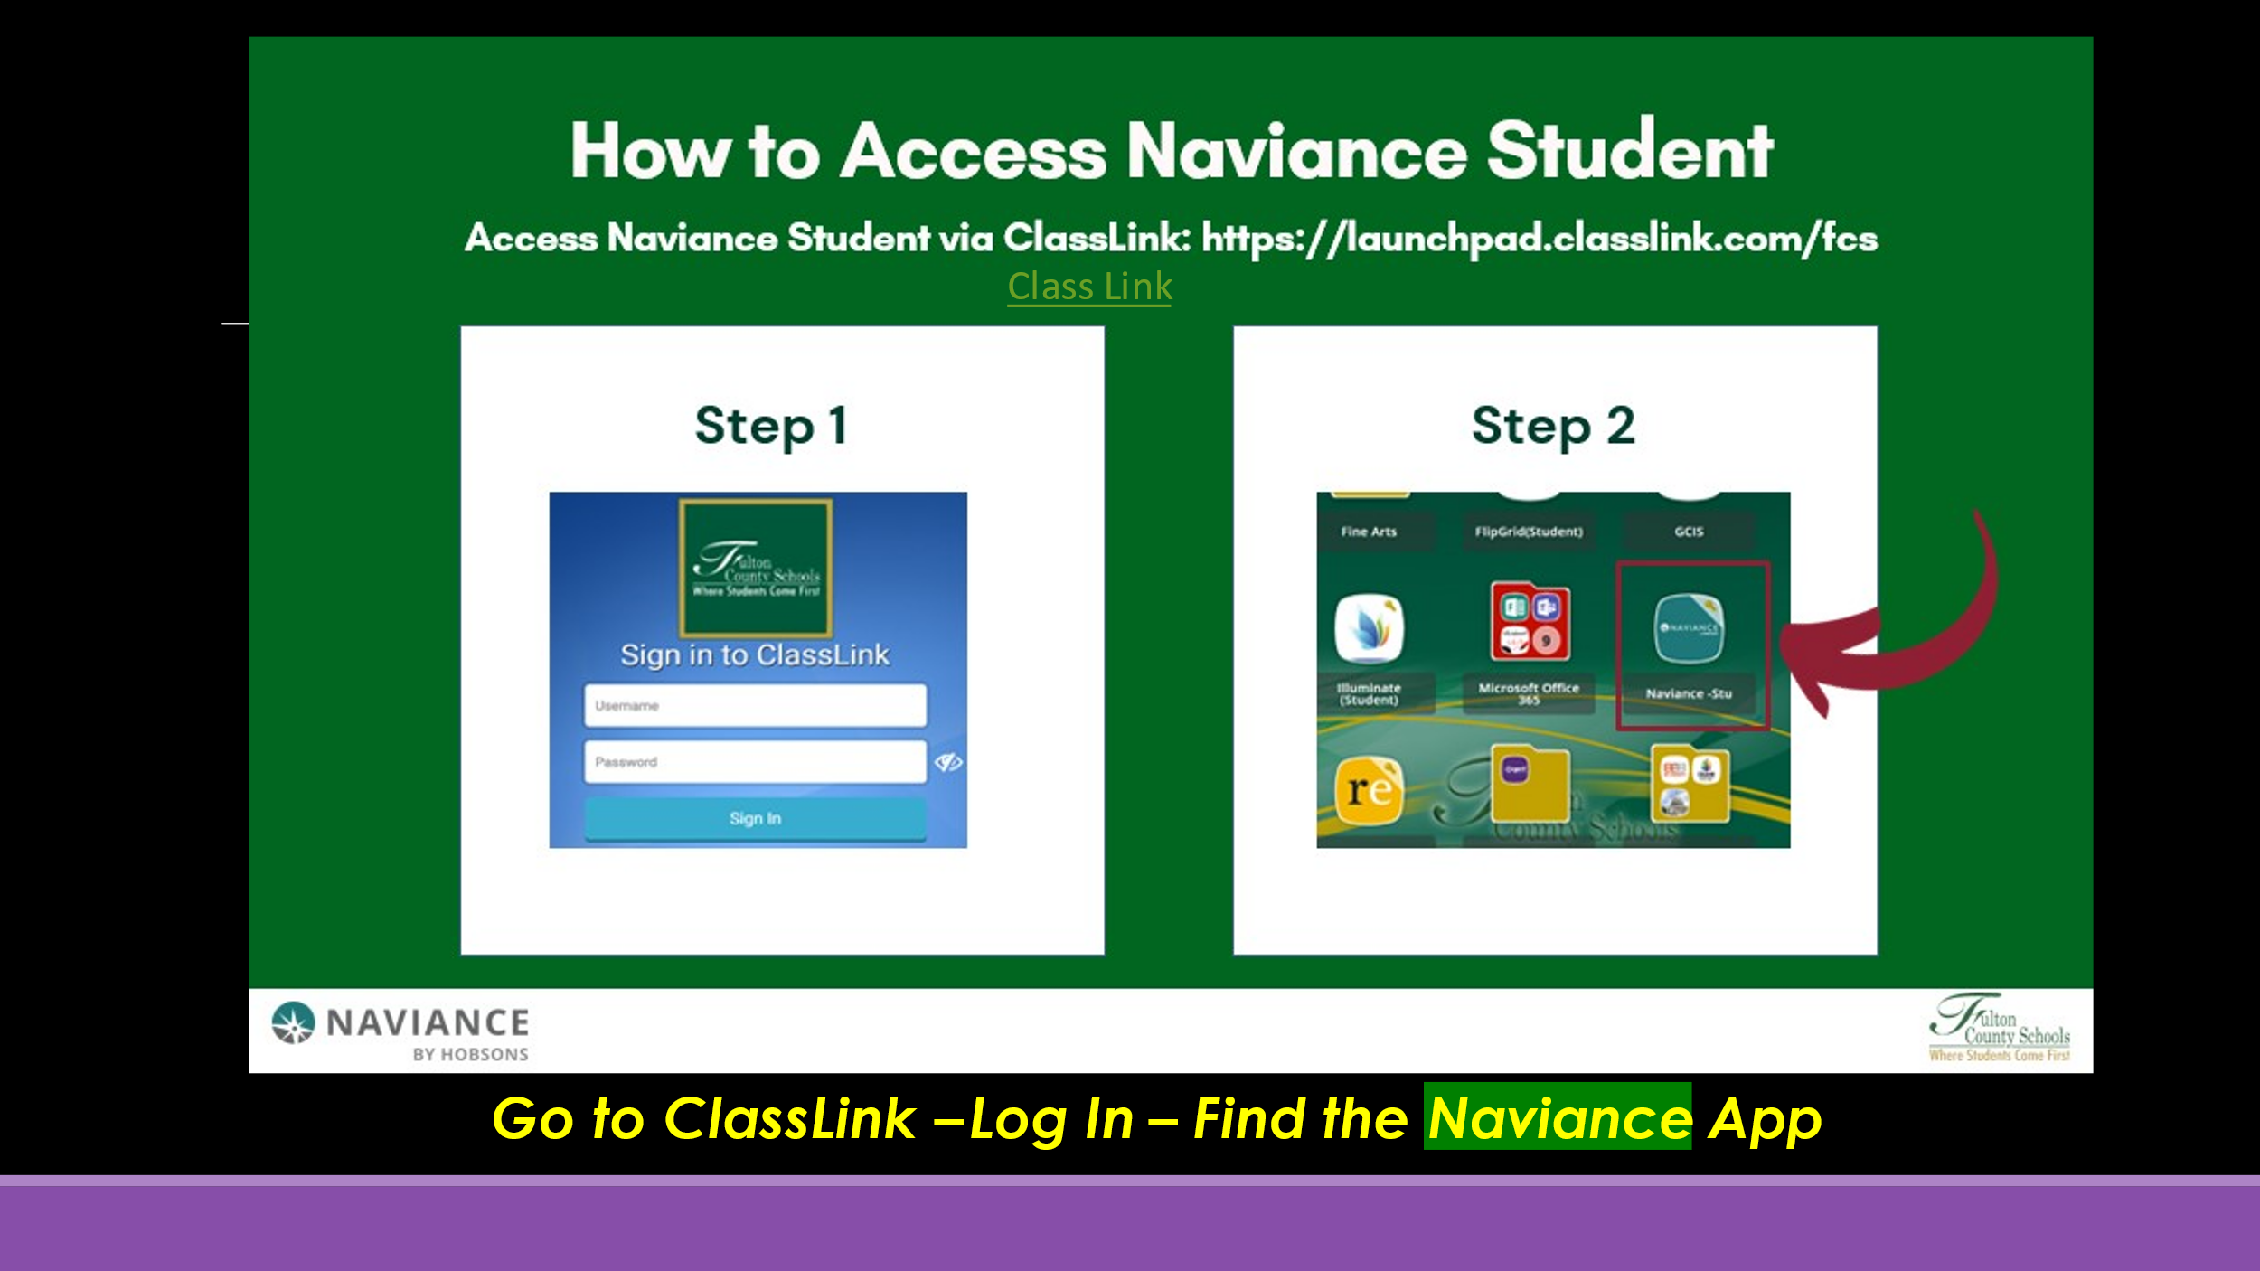
From your home screen, you will see that three tasks are assigned to you:
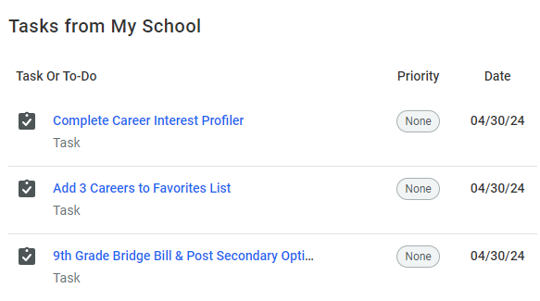
Complete the three tasks assigned to you in this order:
- 9th Grade Bridge Bill & Post Secondary Options Lesson
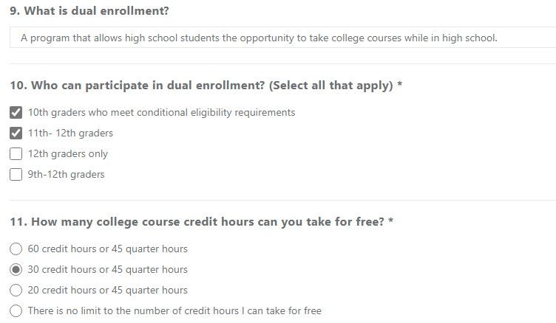
- Career Interest Profiler
- Add 3 Careers to Favorites List
Once you have completed all three tasks, please ask your teacher to confirm that you do not have any remaining tasks to complete.
