10th Grade Bridge Activity – Student Instructions
Log on to Naviance through Classlink:
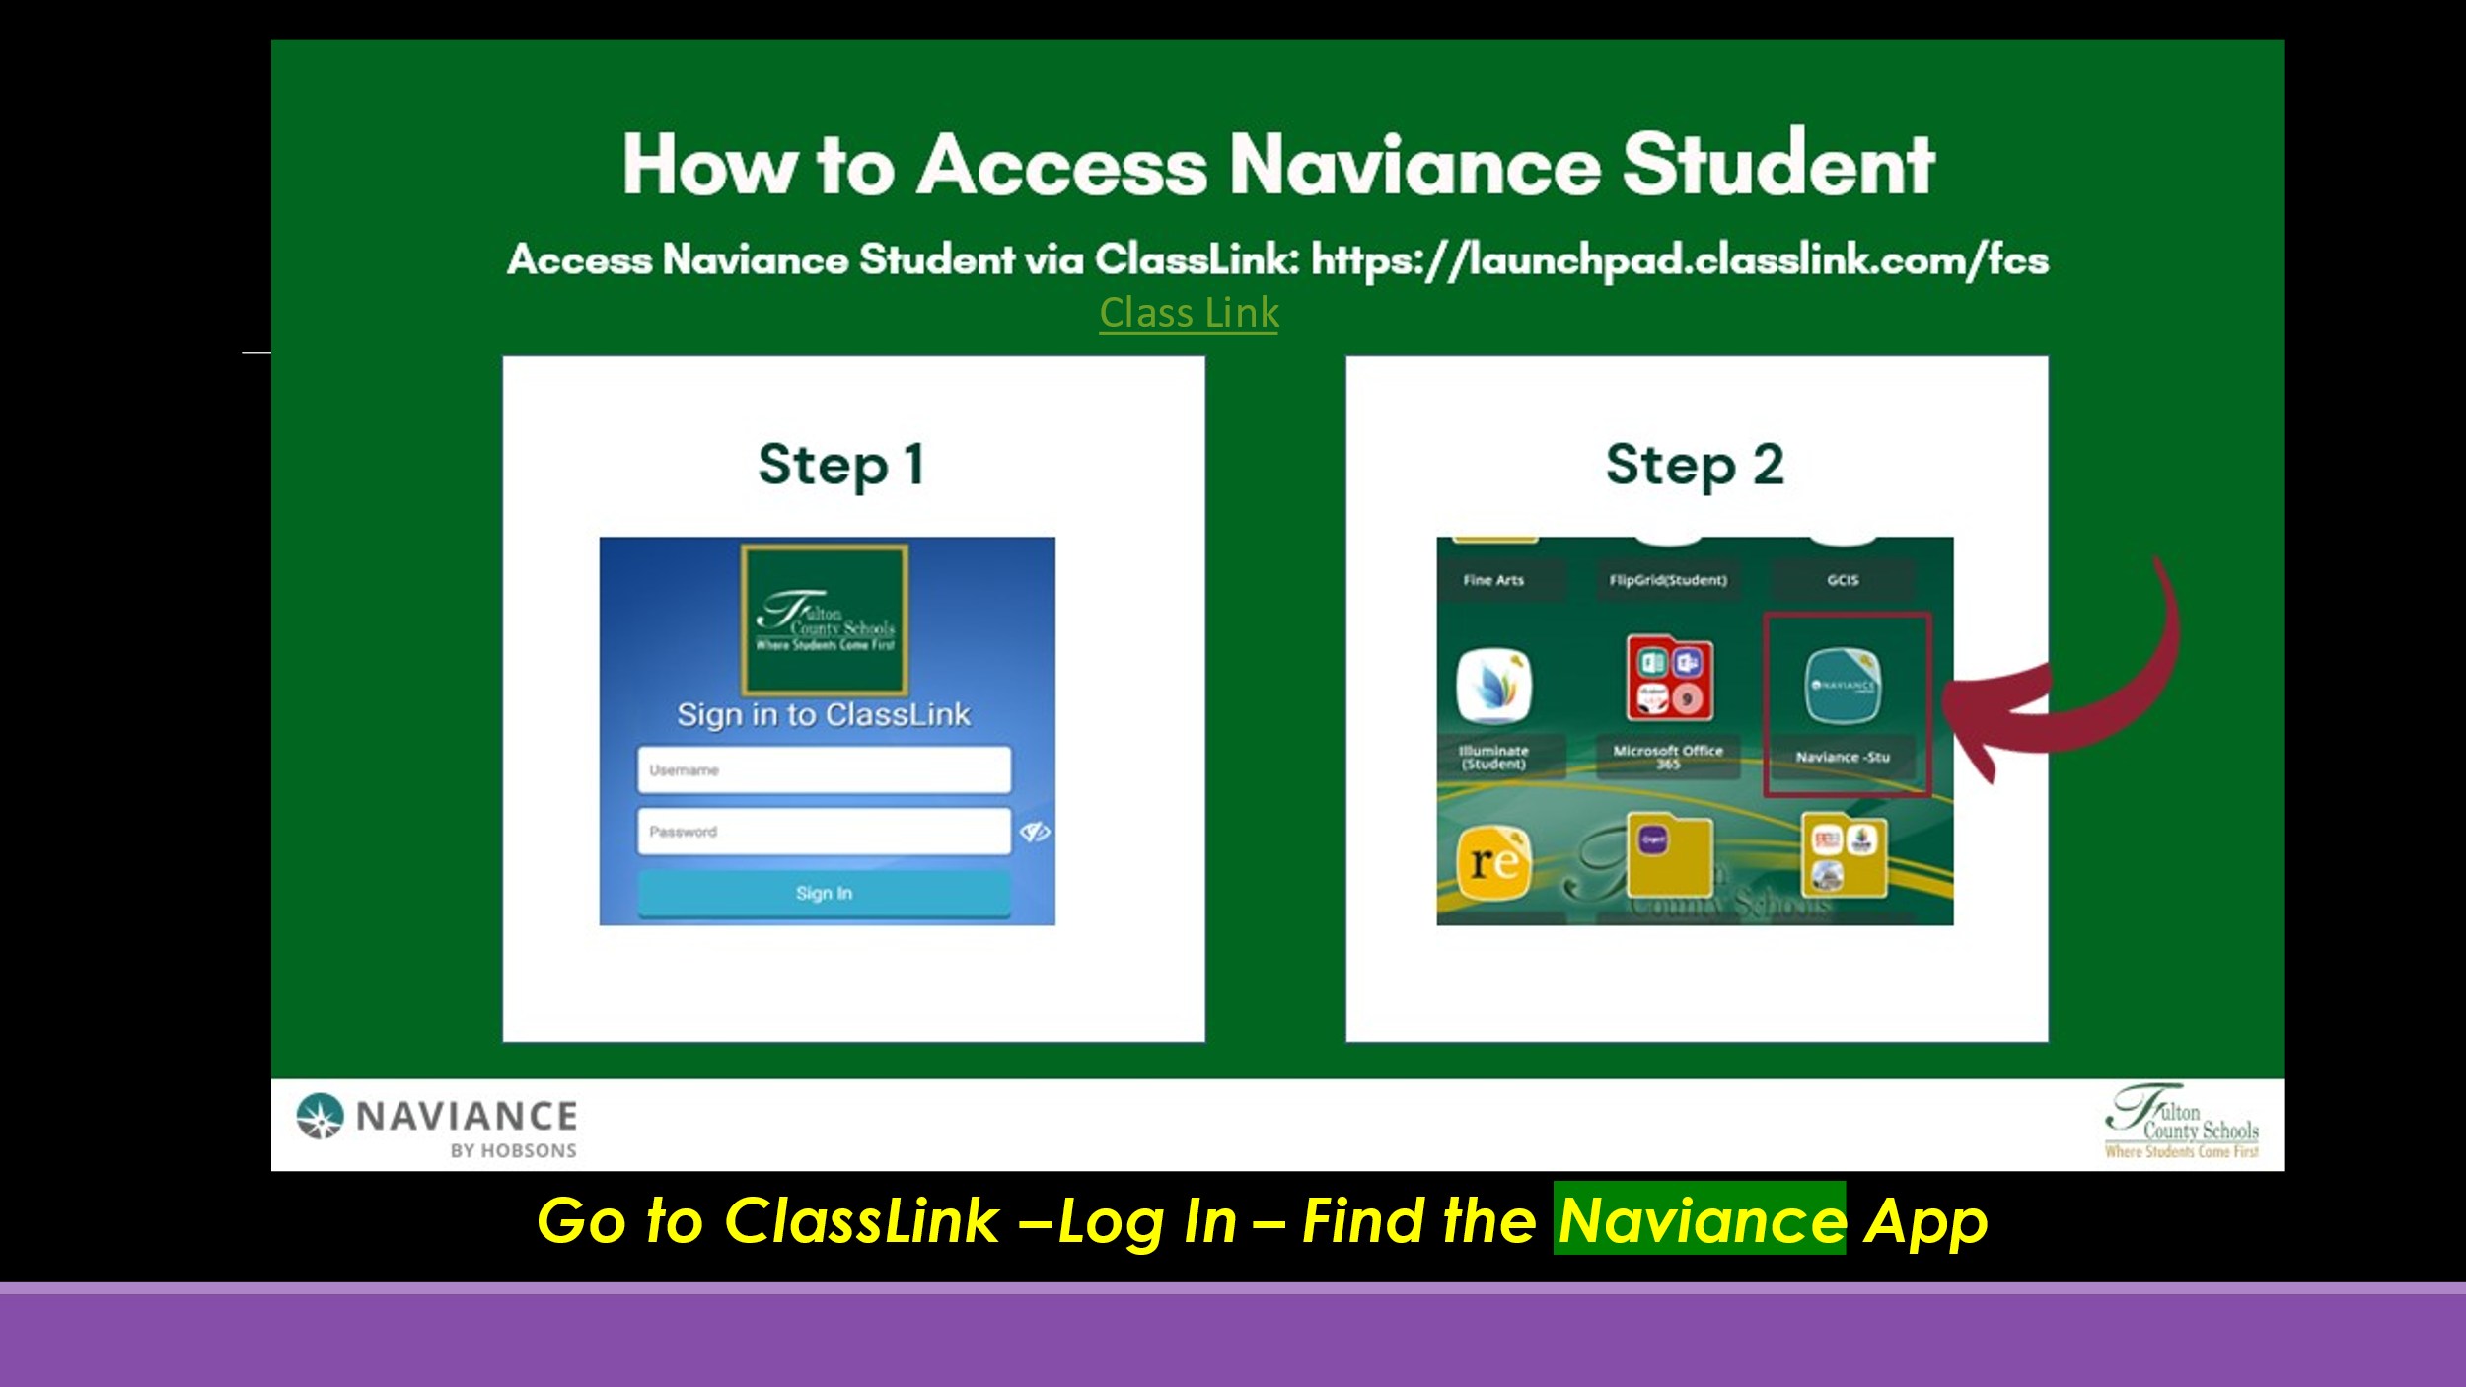

From your home screen, you will see the task assigned to you:
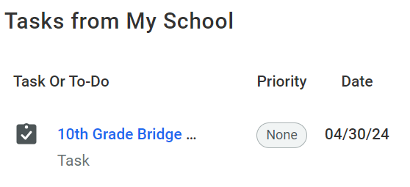
Click on the words 10th Grade Bridge Bill & Survey
Complete the survey by clicking on “TAKE THIS SURVEY”:
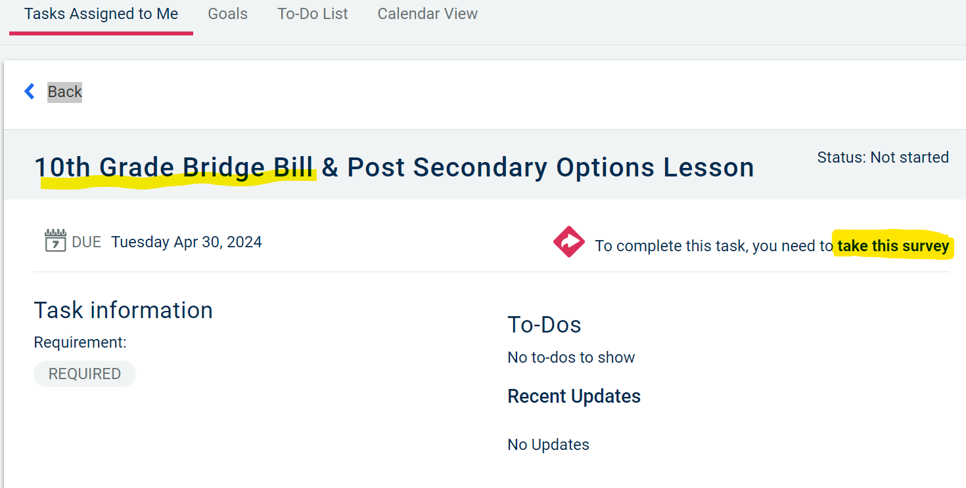
Answers to the questions about dual enrollment:
